Selenium WebDriver
Session: 3
Topics:
# | Subject name
1 | Basic Browser Navigation methods  Maximize(), Minimize(), refresh(), restore(), back(), forward(), getTitle(), getCurrentURL() methods
2 | Basics of HTML  Tags, Attribute, Text
3 | Firebug and Firepath
3 | Locators in Selenium and element identification  Types, Merits and Demerits of each type of Locator
4 | XPath and its Types  Merits and Demerits of each type of XPath
- Basic Browser Navigation methods
Method Name | Code | Description
Maximize | driver.manage().window().maximize(); | Maximizes the browser window
refresh() | driver.navigate().refresh(); | Refresh the currently opened browser
back() | driver.navigate().back(); | Navigates to the previous URL opened
forward() | driver.navigate().forward(); | Navigates to the next URL opened
to() | driver.navigate().to(“<URL of appl>”); | Opens the specified URL in browser
getTitle() | driver.getTitle(); | Returns title of opened URL
getCurrentURL() | Driver.getCurrentURL(); | Returns the currently opened URL
Get() | Driver.get(“<URL of appl>”); | Opens the specified URL in browser

- Basics of HTML:
- Since Selenium is Web application automation tool and most of the web pages are designed using HTML.
- HTML: Hyper Text Markup Language
- HTML is not case sensitive and has pre-defined tags
- HTML code has following 3 parts
  - Tag: Any text present next to “<” (Open angular brace)
  - Attribute: Any text present immediately after Tag before “>” (Close angular brace)
  - Text: Any text present after “>” (Close angular brace) and before the end of the tag (</>)
- FireBug and Firepath
FireBug: Used to view of the HTML code of the required web element in the web page
Present as Add-on in Firefox browser and can be installed by searching for “firebug” in “Add ons” section
Firepath: Used to view the XPath or verify whether the XPath written is correct or not
Present as Add-on in Firefox browser and can be installed by searching for “firebug” in “Add ons” section
- Locators in Selenium and element identification
- Locators are mainly used to locate/ identify an element in a webpage
- There are 8 types of locators available. They are:
- tagName
- Id
- Name
- className
- linkText
- partialLinkText
- Xpath
- CSS selector
- All the above mentioned locators are the static methods present in “By” class
Element/ Object identification:
- Any element present in the webpage is referred as “Web Element”
- It is concluded any type of web element in web page can be identified using the above mentioned locators
- In order to identify any element in the web page, first we need to know the HTML code of that element and later we can locate/ identify that element by writing the below code
WebElement <variableName> =driver.findElement(By.tagName(“<Name of the Tag>”));
Ex: WebElement username = driver.findElement(By.tagName("input"));
- Return type of “findElement” method is “WebElement” as mentioned above
Different Locators and its merits and demerits
<html>
<head>
<title>Oracle</title>
</head>
<body>
UserName:<input type="text"> <br> <br>
Password:<input type="text"> <br>
<input type="button" value="Login"> <br>
<input type="checkbox">"Remember Password" <br>
<a href = "https://www.facebook.com/" title="ClickHere">Forgot Password</a>
</body> </html>
UI displayed for the above HTML Code is as follow
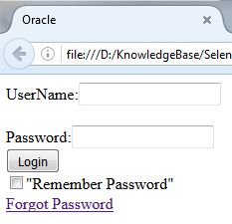
- tagName
In order to click on “Forgot Password” link in the above UI, we need to first identify/ locate the “Forgot Password” link
Locating the “Forgot Password” link:
- In the UI, Right click on “Forgot Password” link and select “Inspect with FireBug” option; HTML of “Forgot Password” is highlighted and displayed the console
OR Click on FireBug icon in the toolbar and then select the inspect button and hover the mouse on “Forgot Password” link
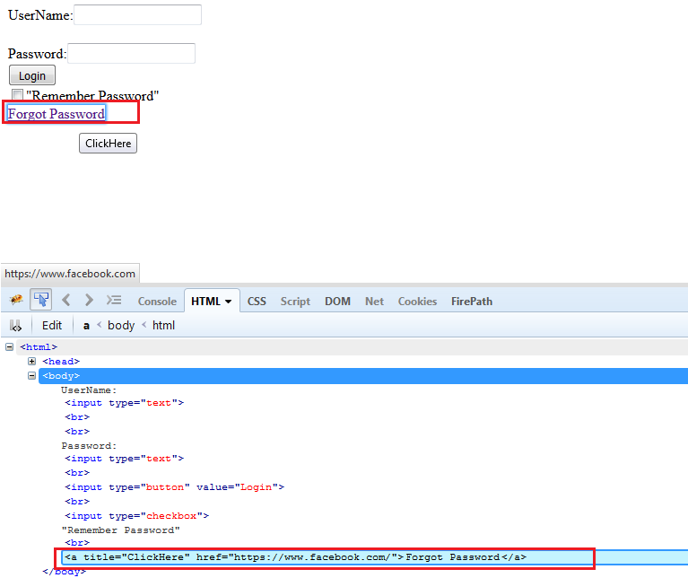
<a title="ClickHere" href="https://www.facebook.com/">Forgot Password</a>
From above code, Tag name= “a”, Attribute= title="ClickHere" href=https://www.facebook.com/
Text=”Forgot Password”
- Hence the code to locate “Forgot Password” would be:
Ex: WebElement forgotLink = driver.findElement(By.tagName("a"));
Demerits:
- All the elements in the webpage cannot be identified using tag Name
Ex: If we try to identify the “User Name” and “Password” text box in the above UI, the code to locate Username would be: WebElement username = driver.findElement(By.tagName("input"));
Similarly Password would be: WebElement pw = driver.findElement(By.tagName("input"));
When we try to enter any text in “username” and “password” text box then always the text is entered in “username” text box rather than “password” text box since the code to identify both elements is same. i.e., driver.findElement(By.tagName("input"));
2. id
- Open Facebook page
- Inspect the “Email or Phone” text box using firebug and observe the below HTML code is displayed
<input id="email" class="inputtext" type="email" data-testid="royal_email" tabindex="1" value="ravikumar.sathe@gmail.com" name="email">
- From the above code, we can identify the “Email or Phone” text box using id=”email” uniquely as: driver.findElement(By.id("email"))
- Finding an element using “id” is considered as fastest among all other locators.
Demerits:
- There might be a possibility like multiple elements has same id
- Some of the web elements will not be having id
Ex: On inspecting “Forgotten account?” text in “Facebook” page, the HTML code displayed is as follows:
<a data-testid="forgot_account_link" href="https://www.facebook.com/recover/initiate?lwv=301">Forgotten account? </a>
In the above code, there is no “id”
- name:
- Open Facebook page
- In “Create new account “First Name” text box and observe that the below code is displayed
<input id="u_0_1" class="inputtext _58mg _5dba _2ph-" type="text" aria-label="First name" placeholder="" aria-required="1" name="firstname" data-type="text">
- From the above code, we can identify the “First Name” text box using name=”firstname” uniquely as: driver.findElement(By.name("firstname"));
Demerits:
- All the web elements might not be identified using only “name” locator
- Some of the web elements may not have “name” as attribute
- Sometimes multiple elements will match on using “name” locator

- className:
- Open www.irctc.co.in webpage
- Inspect “User ID:” text box and observe that the below HTML code is displayed
<input id="usernameId" class="loginUserId" type="text" tabindex="1" maxlength="35" size="15" autocomplete="off" name="j_username">

- From the above code, we can identify the “User ID” text box using name=”loginUserId” uniquely as: driver.findElement(By.name("firstname"));
Demerits:
- Very rarely used type of locator to locate any element
- “className” locator is normally used to specify the class to which an element belong to in HTML code.

5. linkText:
- Normally used to identify any link present in the web page
- Open https://www.makemytrip.com/ page
- Inspect “HOLIDAYS” link and observe that below HTML code is displayed <a class="hdr_item_link" href="https://www.makemytrip.com/holidays-india">holidays</a>
- From above code, we can derive the code for “HOLIDAYS” link as follows: driver.findElement(By.linkText("holidays"));
Note:
- “linkText” locator is not used to identify any normal text

Ex: Open LinkedIn website and inspect text “Be great at what you do” which is not a link but a normal text. HTML code for it is: <h2 class="title">Be great at what you do</h2>

We cannot write the code: driver.findElement(By.linkText("Be great at what you do"));to identify this element

Link will normally be written using the HTML Tag “a”
6. partialLinkText:
- Used to identify dynamic link text (Link which changes from time to time)
Ex: “Inbox (xx)” in Gmail account. Here “xx” indicates the number of unread emails which changes from day to day.
In this case, we can identify “Inbox” element as: driver.findElement(By.partialLinkText("Inbox"));
Demerits:
- Both “linkText” and “partialLinkText” is used to identify only links in the webpage.
Xpath:
- Most widely used locator which helps to identify any element in the webpage uniquely
- XPath is the path of the web element in the HTML tree

Consider the below HTML code:
<html>
<body>
UserName:<input type="text">
Password:<input type="text">
<a href = "https://www.facebook.com/" title="ClickHere">Forgot Password</a>
</body>
</html>
Skeleton of the above code is as follows:
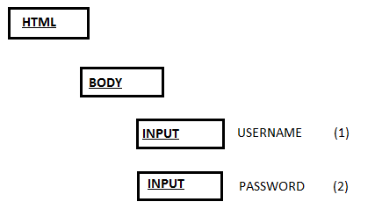
In order to locate “USERNAME” text box in the above HTML tree/ code, we need to navigate as:
HTML-> BODY-> INPUT (1)
Similarly to locate “PASSWORD” text box, we need to navigate as:
HTML-> BODY-> INPUT (2)
- XPath is classified into below types:
  - Absolute XPath
  - Relative XPath
  - XPath by Attribute
  - XPath by Text function
  - Independent and Dependent XPath [Forward and Backward Traversing]
Absolute XPath:
- If we specify the complete path of the element starting from the root, it is known as Absolute Xpath
- Single forward slash (/) is used to navigate to the immediate child
Ex:
<html>
<body>
<div>
<input type="text" value="A">
<input type="text"value="B">
</div>
<div>
<input type="text" value="C">
<input type="text"value="D">
</div>
</body>
</html>
HTML Tree:
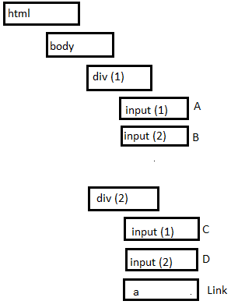
Absolute XPath Table:
/html/body/div[1]/input | A, B
/html/body/div[1]/input[1] | A
/html/body/div[1]/input[2] | B
/html/body/div[2]/input | C, D
/html/body/div[1]/input[1] | C
/html/body/div[1]/input[2] | D
/html/body/div[2]/a | Link
/html/body/div[2]/a[1] | Link
/html/body/div/a[1] | Link
/html/body/div/a | Link
Disadvantages:
- Absolute Xpath are very lengthy and is not feasible to use it in real time application
Relative XPath:
- Provides the user with flexibility to navigate to any element in the tree directly without navigating through each element in the tree from root
- Double forward slash (//) is used to represents any element in the tree
Ex: Relative XPath for all elements for above HTML tree
//input | A, B, C,D
//div[1]/input | A,B
//div[2]/input | C,D
//div[1]/input[1] | A
//div[2]/input[2] | D
//input[1] | A,C
//input[2] | B,D
//a | Link [XPath to get all links in Web page]
//a[1] | Link
Disadvantages:
- Difficult to identify the elements uniquely using Relative XPath and Absolute XPath
- We cannot always use indexing to identify an element in real time application.
XPath by attribute:
- Identifying the element using attribute of the element
- Syntax: //<htmlTage>[@PropertyName=’<PropertyValue>’]
Ex: Identifying the ‘Email or phone’ text box in Facebook using Xpath by attribute
//input[@id='email']
XPath to identify all Check boxes | //input[@type=’Checkbox’]
XPath to identify all Buttons | //input[@type=’button’]
XPath to identify all Check boxes and Buttons | //input[@type=’Checkbox’]| //input[@type=’button’]
- This is the mostly widely used XPath to identify an element in a web page
Disadvantages:
- If a particular element doesn’t have any attribute defined then we cannot use XPath by attribute
- If more than one element matches on using XPath by attribute concept then we cannot use.
XPath by Text:
- Identifying the element using text value associated with the element
- Syntax: //<htmlTage>[text() =’<TextValue>’]
Ex: Identifying the “Forgotten account?” link in Facebook using Xpath by text
//a[text()='Forgotten account?']

Note:
- If there is any non breakable space (nbsp) in text value or property value then we cannot identify the elements using Attribute of text directly
Instead we can use contains function to verify the presence of complete text/ attribute OR partial text/ attribute
Syntax: //<htmlTag>[contains(@PN, ‘PV’)] PN=Property Name, PV= Property Value
//<htmlTag>[contains(text(), ‘TV’)] TV= Text Value
Ex: //input[contains(@value, ‘Create Billing Type’)]
//input[contains(text(), ‘Delete’)]
Dependent and Independent XPath:
XPath Traversing:
2 Types:
- Forward Traversing
- Backward Traversing
Forward Traversing:
- Navigating from Top to bottom OR Parent to Child in an HTML Tree
- We will use “/” or “//” to navigate to any element in the HTML Tree in forward direction
Ex: /html/body/input[1]
//div[1]/input[1]
//input[@type=’Checkbox’]
Backward Traversing:
- Navigating from Bottom to Top or Parent to Child in an HTML tree
- We will use “/..” to move to the immediate parent of the current web element. we can use “/..” again to go back to its parent
Ex: Navigating to the parent of “Java” in “SeleniumHQ” website
//input[text()=’Java’]/../../..

Alternative names and sign conventions
/ | /child:: | To go to immediate child | /html/body/child::input
// | /descendent:: | To go to any child
/.. | /parent:: | To go to immediate Parent
NA | /ancestor:: | To go to any parent
- In order to handle dynamic or duplicate elements we will use “Independent and Dependent XPath” concept
In order to identify the elements using Independent and Dependent concept, we will have to follow the below steps:
- For a given web element, note down the “Independent” and “Dependent” web elements
- Find the XPath of the “Independent” element
- Traverse in upwards direction (Backward direction) in HTML tree using mouse till both independent and Dependent elements are highlighted
- Now traverse downward (Forward direction) till dependent element is identified. This results in the XPath to identify the dependent element for the given independent element
Ex: Identifying “Download” link corresponding to “Java” in “SeleniumHQ” website
Steps:
- Go to official website of Selenium- “seleniumhq.org”
- Click on “Downloads” link in the top of the web page
- Now click on “Download” link next to “Java”
Here “Java” is the independent element where as “Download” is dependent element.

public class Xpaths {

public static void main(String[] args) {

WebDriver driver = new FirefoxDriver();
driver.get("http://www.seleniumhq.org");
driver.manage().window().maximize();
driver.manage().timeouts().implicitlyWait(10, TimeUnit.SECONDS);
WebElement DownloadLink = driver.findElement(By.xpath("//a[text()='Download']"));
DownloadLink.click();
WebElement JavaDownloadLink = driver.findElement(By.xpath("//td[text()='Java']/..//a[text()='Download']"));
JavaDownloadLink.click();
}
}
Group Index:
- If we are unable to identify an element using any of the above mentioned locators then we can use “Group Index” concept
- Here, if a particular XPath matches with multiple elements then we will identify each element by grouping it and providing index value
- Syntax: (<XPath to identify group of elements>)[<index>]
Ex: [refer: HTML tree and HTML code provided in Absolute XPath section]
XPath to identify 1st Input type of element: (//input)[1]-A
XPath to identify 4th Input type of element: (//input)[4]-D
XPath to identify last checkbox type of element: (//input[@type=’Checkbox’])[last()]
XPath to identify 1st & last check box:
(//input[@type=’Checkbox’])[1]| (//input[@type=’Checkbox’])[last()]
Converting XPath to CSS (Cascading Style Sheets) Selector:
- Every browser has its own engines to interpret the HTML code and for this reason, hence the XPath written on one of the browser may not work on another.
But CSS Selector is browser independent hence we can convert XPath to CSS as follows:
XPATH | CSS SELECTOR
//a | A
//input[@name=’un’] | Input[name=’un’]
//input[@id=’login’] | Input#login
//input[@class=’username’] | Input.username
//table/tbody/td | table>tbody>td
//td/../.. | NA
//a[text()=’login’] | NA
//tbody//td | tbody td
//a[1] | a nth – child[1]

